CERTIFICATE OF
APPRECIATION
Presented To

LOYAL CONTRIBUTOR
FOR 10 YEARS OR MORE
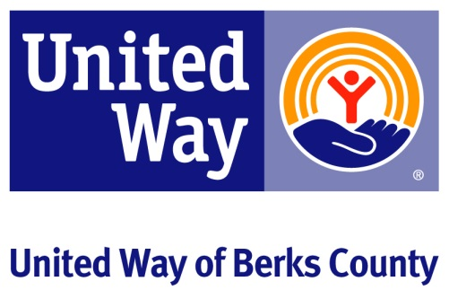
United Way of Berks County
www.uwberks.org

