Watch an agency video on  United Way’s  Video Galley | Talk to a new employee about United Way | Make United Way of Berks County your Amazon Smile benefactor | Donate non-perishable food to an agency in need | Learn about  United Way’s Response to COVID
Participate in 1 of COMPANY’s Special Events | Attend a UW COMPANY meeting  (in person or virtually) | Increase your pledge from last year OR be a new giver this year | Educate a  co-worker on 211 | Participate in Day of Caring 2021
Share this BINGO and encourage  co-workers to play | Search for a volunteer opportunity at uwberks.org | 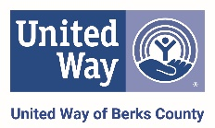 | Post on social media about a volunteer project | Learn about United Way’s  4 Focus Areas
Read a success story on United Way’s blog | Clean out your closet and donate gently used clothes to area non-profit | Follow United Way of Berks County on social media @uwberks | Subscribe to United Way’s quarterly  email newsletter | Leave an encouraging note in a coworker's email inbox

