CEO Endorsement Letter

I am very proud of the (company name) team for many reasons – your commitment, dedication, resilience and your caring heart.
Our team takes pride in building a strong company, as well as a strong community. One way we make a difference is through our participation and support of our annual United Way campaign. (Company Name) believes in the effectiveness, efficiency and accountability of partnering with United Way of Berks County. Supporting United Way’s work provides confidence that dollars contributed are well spent right here in Berks County.
I am a true believer in the idea that we can make our community a better place, but we can’t do it alone. TOGETHER, we help people like Willie –
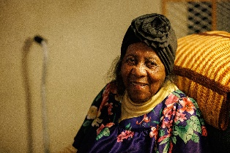
Willie is 98 and treasures living in her own home and spending time with family. She faces health issues, which makes cooking for herself unsafe. Willie turned to Meals on Wheels, funded by United Way of Berks County, for help. Because of your support, she receives nutritionally rich meals each weekday, delivered by volunteers. The volunteers keep an eye on Willie and report any concerns while providing a friendly visit – often her only visit of the day. Willie remains in her home, in part, because of Meals on Wheels. She is one of 190,000 people who receive help because of your leadership and support.
Please join me in being a part of something that helps so many. Our company’s campaign kicks off on (date). And, join me in thanking our fellow team members, (names), for serving as committee members helping to coordinate our campaign efforts, along with several exciting campaign incentives like (incentive detail).
Thank you for Living United!
CEO Name

