Leaders United Letter

YOU inspire others!
As a Leaders United member, you lead the way as one of our community’s most generous individuals. By partnering with United Way of Berks County, you help children reach their full potential, help families achieve financial stability and help Berks Countians most-in-need.
It is your support that allows United Way to invest in high priority and high performing programs delivered by our agency partners to help more than 190,000 Berks Countians…like Harrison.
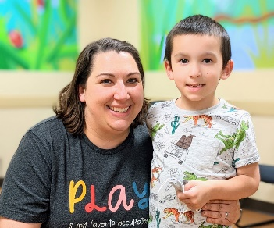
Meet Harrison. His autism diagnosis makes life as a second grader a little more challenging. Harrison is learning how to manage his autism through therapy he receives from United Way agency partner, Easterseals. His therapy helps him with strategies for learning and making friends.
When you invest in United Way, you create lasting change right here in our community. The money raised here stays here to improve access to education, income and health so all Berks Countians can thrive.
Your gift can be multiplied through the 2023 Challenge Match. With YOU, we have the power to do more and make a greater difference. Consider how, together, we can provide more help and hope:
• Increase your gift to the next level, and your entire gift will be matched
• Increase your gift within a level, and your increase will be matched
Thank you for your generosity and making an incredible impact on the lives of children, families and seniors across Berks County.

