Retiree Letter

Dear (Retiree Name),
As part of the (Company Name) family, you have helped create a strong company, as well as a strong community. By partnering with United Way of Berks County, together, we have supported issues that matter to all of us and helped children become stronger readers, helped families gain financial stability and allowed more Berks Countians to live healthier lives.
As you enjoy your retirement, we invite you to continue supporting United Way through (Company Name)’s annual campaign. Simply complete the enclosed campaign pledge form (or click here, etc.) by (date). Giving to United Way is an easy way to make a powerful impact in the lives of many.
Lives like Willie…
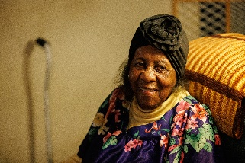
Willie is 98 and treasures living in her own home and spending time with family. She faces health issues, which makes cooking for herself unsafe. Willie turned to Meals on Wheels, funded by United Way of Berks County, for help. Because of your support, she receives nutritionally rich meals each weekday, delivered by volunteers. The volunteers keep an eye on Willie and report any concerns while providing a friendly visit – often her only visit of the day. Willie remains in her home, in part, because of Meals on Wheels. She is one of 190,000 people who receive help because of your leadership and support.
United Way can also help you explore different activities through its Volunteer Center. We know you have much to offer, and you may now have some extra time to participate in meaningful volunteer activities. Learn about a range of opportunities by visiting uwberks.org/Volunteer.
Thank you for continuing to share your caring spirit and for making a difference!

Sincerely,
CEO Name

