CEO Endorsement Letter

I am proud to work with a dedicated and hard-working team—people who don’t just show up for work, but who show up for our community.
We all believe that when you invest in the community, you help it grow. That’s why (Company name) partners with United Way to build a stronger Berks County. Their work ensures children are prepared to start school and achieve academic success, provides meals for families facing hunger, and helps our most vulnerable neighbors meet their basic needs.
Your support provides help to real people, like the Drexler family. Nancy, 90, needed skilled care after having a debilitating stroke. Her family connected with United Way agency partner, Tower Health at Home, when hospice care was needed. Nancy’s daughter, Joanne, was grateful for the professional and compassionate support provided to her mom and describes her mother’s passing as peaceful. She valued the comfort provided by the Hospice team.
Losing a loved one is never easy, but United Way funded programs like this bring peace during a difficult time.
Supporting United Way is one of the most powerful ways to improve lives and make a difference. Their work is all about doing right—right here, in the place we call home.
Please join me in making a difference in our community. Our company’s campaign is kicking off on (date), and we are so grateful to our fellow team members, (names), for stepping up as committee members to coordinate our campaign efforts. They have helped to bring some exciting incentives to make giving even more rewarding, like (incentive detail).
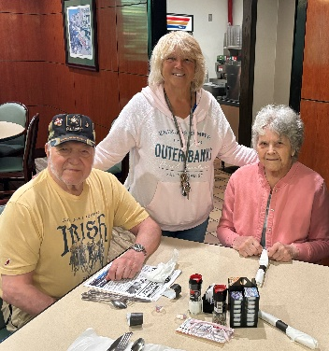
Hope starts with you, and together, we can transform lives—one act of generosity at a time.
Thank you.
CEO Name

