Leaders United Letter

Dear (Employee Name),
United for opportunity - - this is what is at the heart of United Way’s work, focused on helping children achieving academic success, connecting people to the help they need and helping our neighbors live stronger lives.
As a valued Leadership Giver, you play an essential role in strengthening our community through your generosity and commitment. Your support transforms lives across Berks County and helps children and families thrive.

When Karen adopted her homeless grandsons, Oliver and Coda, she was determined to give them a stable and loving home. The children had faced more hardship than most their age, battling developmental delays, speech difficulties, and behavioral struggles.
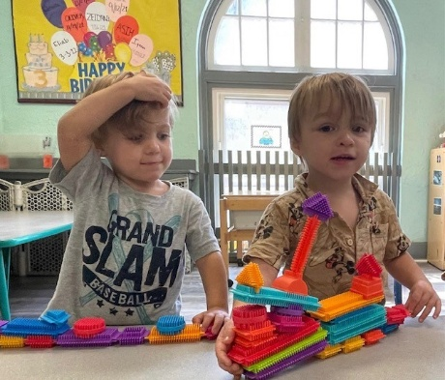
Karen turned to the United Way-funded YMCA childcare program for structure, safety, and support. Thanks to the programs and the YMCA toddler teachers, Oliver and Coda began to transform. They learned to express themselves, gained confidence, and reached milestones that once felt out of reach. They found stability and a future filled with promise. Today, they continue to progress.
Karen shares gratitude for the United Way supported program. "This childcare program allowed me to continue to work, as well as helped me gain additional support to help my grandchildren meet and achieve developmental milestones.”

As we launch this year’s United Way Campaign, we ask you to continue making a meaningful impact. Together, we ensure more children are able to read at grade-level, more families have access to healthy, nutritious food, more seniors are able to stay in their homes and our neighbors are supported with emergency services in times of crisis.
(Company Name)’s United Way campaign begins on (date), and I invite you to join me at one of our upcoming campaign events. Hope for people like Karen and her grandchildren, Oliver and Coda, begins with you.
Thank you for leading the way and doing right, right here.
CEO Name

